Aidan Bliss
Sewanee Art Department
Art 430
28 April 2018
Nowhere to go, nothing to shoot is the title of thematically connected work created from the second half of 2017 up to the present. It is, in part, an artistic rendering of the vast variance of motivations behind each click snap or pop of a shutter that creates a photographic image. Photographs and collages within this body of work examine the degree to which photographers express themselves through their images, inspired by instances in which an image conveys something exterior to the ideas that it was shot with. The series discusses reconciling an individual artistic identity with existence in the information era – a time that is notably saturated with media and images – and questions the viability of a unique identity in a cacophony of visions. Certain pieces within this body of work seek to dissolve a specific artist entirely as the possibility of unconscious photography is considered. The aforementioned title implies a feeling of paralysis; it illustrates a block in the processes through which artists forge their own destinies and find nuanced meanings behind their work. As it explores our understanding of what is socially considered as "worth" shooting, and how modern exposure to large volumes of images factors into that assessment, Nowhere to go, nothing to shoot is a visual study of the trepidations, anxieties, and occasional serendipity of contemporary image creation.
The intersection between photography and technology has been such that there is significant improvement in the ease and access to image making as time passes. This increasing optimization is relevant when considering the work presented in this series because much of it is inspired by an anxiety unique to a 21st century capitalist society's utilization of photography. It's not an entirely new issue; in fact it's been an issue since photography's beginnings, but it has been continually amplified in bursts with milestones such as the introduction of the 35mm, then the disposable camera, then to digital, and then to the current practice of fitting a camera into phones or even, say, glasses¹. Owning a cellphone now often means also owning a camera. The best way to paint a picture might be to take one, as photography is versatile enough to where it can be fine art, an advertisement, a scandal, a record; essentially anything that can be photographed can be and will be. To say that a tech-savvy society is saturated with images seems like an understatement, as photographs envelop just about any realm of inhabitants intrigued by screens.
This enveloping with images has a multitude of consequences that have inspired work in nowhere to go, nothing to shoot. A combination of high content volume and accessibility creates a stream of consciousness effect with pictures experienced on the daily, especially via the common practice of half-aware scrolling through Internet feeds. The vague spaces associated with stream of consciousness are visualized in pieces such as ambient_1-4, while its clutter and layers are visible in collages levi and untitled. Images possess new functionality in realms such as Instagram and Snapchat, where photos might be curated to meet some visual specificity² or be intended to last merely a manner of seconds – within the timespan of a solitary thought. The simple transfer of images has become a unique form of web-based communication as photography evolves its own new language. Printed work, by comparison, can sometimes feel somewhat past tense³ and perhaps imbued with a greater nostalgic value. The singular photo may seem smaller than ever in the face of mass net uploads; if a picture is worth a thousand words then that's 350 billion words per day on Facebook alone, in 2013⁴. It is overwhelming to consider. The dichotomy here is one of countless lost pictures, what a 2015 MoMA exhibition on contemporary photography called "a vortex of images⁵". Aspiring photographers are subject to anxiety¹¹ as they attempt to navigate their vein of the art world, with careers in the field often considered as being risky or financially unstable. In the age where it seems that everything that can be photographed already has been, there's a greater sense of finding nothing to shoot in the face of established clichés, irony, and stifling aestheticization.
This work's navigation of photographic ennui begins with an anecdote. Eight years ago, a disposable camera was purchased for a weeklong Boy Scout camp excursion, merely intended to capture a log of experience there. The end result was 24 nameless photographs, with the one featured in this document being a flash photograph of cafeteria food (fig. 1). In a culture that places high value on the visual, on things being seen, this print bears the classification of being an unseen photograph, a glossy 6x4 left to gather dust with socks and underwear in the back of a top drawer. The food presented in untitled is unappetizing and low quality, with the disposable flash and unpleasant green of the plastic tray heightening the sense of these peculiarities. Action, or a sense of a specific moment, is somewhat lost in the banality of this photograph but for three fingers in the image's upper left-hand corner.
This photograph's relevance to nowhere to go, nothing to shoot is mostly inspirational in its considerations of banality and what is chosen as a subject for photography. It began a mental discourse of what separates an innocent photograph of a banal thing (i.e., shot without the intention of 'time to photograph a boring thing because it's boring') from a photograph that specifically sought out something dull to shoot. The word "disposable" functions as a double entendre in regards to untitled, referencing the disposable camera it was shot with along with its non-preciousness and throwaway quality. It exists as a photograph that achieves very little other than just that - being a simple reminder of the camera's ability to just capture. The disposable camera photograph is an aestheticized relic⁶, foreign to the new technology allowing for an increasingly streamlined process by which one can achieve snapshots that readily satisfy good focus and exposure. This forsaken photo's salvation lies in the ironic retrospective – in which it might be seen as some scathing remark upon male pubescent grime and the American dream – which should probably be left well alone. Its only discernible character exists perhaps in the naïve, pre-adolescent lens through which it was shot, which spurred an interest in the identity behind the camera and discrepancy between photographic intention and photograph.
In line with exploration of the idea of a photograph's varying "lost" or "unknown" qualities, this body of work explores the notion of unconscious photographic capture in the ambient_1-4 pieces. These photographs are attempts at manufacturing an accidental photograph. Manufacturing an accident is conceptually paradoxical; therefore the work reflects a rendering of an impossible ideal, a sketch of some unphotographed assailant on TV. The ambient pieces are abstract, the first (fig. 2) of which featuring an object so close to the lens as to be completely out of focus, rendered as a gradient with a sliver of some exterior world in the upper right hand corner. The photograph also features sparse white marks (also seen in ambient_4) with a cluster towards the bottom-middle range, which is in fact sticky residue on the expired 35mm film it was scanned from. This blemish's inclusion further reinforces feelings of imperfection and the accidental, along with a sense of dreams as it serves as a reminder of reality and the physicality of the negative on top of an indeterminate space. ambient_2 (fig. 3) addresses imperfection through blur and subject matter: an easily dismissible blue sky shot through a moving car's sunroof. All ambient compositions feature large expanses of space - if a busy snapshot is pop music, these photographs are reminiscent of the ambient music from which they are named. Similar to how ambient music might feature drawn-out, drone textures, these photos capture the essence of an abstract plane rather than an applied single moment.
A captured "moment" in photography typically features subjects moving or doing something, which images in the ambient section lack. ambient_1-4 are visually and conceptually calm images. In her 1977 essay, "In Plato's Cave," Susan Sontag writes on human incentive for photographing.
"A way of certifying experiences, taking photographs is also a way of refusing it - by limiting experience to a search for the photogenic, by converting experience into an image, a souvenir. Travel becomes a strategy for accumulating photographs." (Sontag, 9)

With no clear subject in sight, the ambient photographs challenge the idea of a subconscious gravitation towards the photogenic, while also neglecting to force a specific narrative or point in time onto the viewer. There is no essential "information" (a quality which could be considered essential to photography's 'value⁷' as a practice [Sontag, 22]) garnered from viewing these photographs. The presentation of these unknown places, reminiscent in the aged vagueness and distance of the aforementioned untitled, brings with it a sense of abjection from the artist. While untitled utilizes literal temporal distance to achieve this separate self, the ambient photographs strive to create visual spaces in which the viewer can not immediately discern the photographer's exact position or subject matter. It's the fabrication of an unknown point in space-time. This displacing effect heightens the work's perceived calmness through absolving the anxiety of the (perhaps sometimes self-imposed⁸) requirement for unused narrative or concept. While these photographs do not entirely escape aesthetic classifications, they exhibit qualities associated with both fine art photography (i.e. fitting Sontag's model of searching for the photogenic) and snapshot technique, becoming something in between the two. They deny the audience subject matter and action culturally associated with street photography, but maintain their looseness and imperfection.
However, absolution of the photographer's identity is rooted in escapism and is a denial of the artist's inherent presence in any created image. Erasing the triumvirate of subject, moment, and photographer from an image is a technical impossibility that requires a degree of deception to be realized. Rather than trying to erase the presence of a distinct artist entirely, the further work in nowhere to go, nothing to shoot begins to implicate the photographer as a visible participant in the unending sea of images with a distinguishable personality. If all photogenic things are sought out and catalogued to the point of meaninglessness; to the point where an 'original' photograph becomes a socio-technical impossibility, then these two works seek to explore a personalized identity in which this is not the case. This is achieved primarily through the introduction of collaged media, which introduces content that wraps over and under images in order to complicate an otherwise ordinary stand-alone expression.
skellies and yellow (fig. 4 & 5) are unique to the body of work in that they were the first pieces to utilize physical construction paper. Along with other collages in the series, they begin a trend of using a low-key, accessible "core" image at the center that is made less accessible and more complex by the introduction of new textures and images. Rather than attempting to abandon the individual behind the camera as the ambient series endeavored towards, skellies creates a puppet photographer. It is another skewing of photographic identity, this time opting for a child-like lens that might find such Halloween décor compelling, recalling the temporally unreachable lens through which the camp cafeteria photo was taken. The black and white flash image sits in opposition to the red construction paper that it's framed by, suggesting importance being placed on the un-emphasized. The narrative behind this collage's creation is one akin to an elementary school art project, mounting a picture under colored paper for the sake of doing so. It is a naive means of making a fairly disposable image into a more precious object. This photographic gaze is role-playing as an individual whom is newer to the medium, distanced from the desire for fulfilling photogenic images.
On the other hand, yellow's base image is a familiar sight within the photographic canon: a road winding off into the distance in an earthy, red-brown landscape. This is one of many instances of cliché in image making, reflecting a Sontag-esque tendency to seek subjects such as railroads stretching towards the horizon – satisfying a visual line play while also possessing a symbolic quality. A road like that is a robust symbol that has the potential to indicate various different emotions, ranging from melancholy to a sense of hopefulness. Such an image might resonate with multiple people in various different ways, which implies a feeling of impersonality that clashes against the glued on Funyuns® wrapper and yellow/green construction paper. The cut and scrappy quality of the collage element is an antidote to the indifference of the cliché road image, with the tree image sitting underneath the other elements serving as an additional visualization of web-based connectivity through its various limbs and glitch editing. yellow's essential dynamic is that of shifting digital and analog elements, reflecting on the change in the artist's visibility on each level. In the context of the entire collage, the banal road image takes on greater meaning: it's a visual lead-in to not only the artist's idiosyncrasies, such as an unfortunate weakness towards Funyuns®, but also an entrance into the swirl of content existing within the individual and that which encompasses many. This is an antithesis to the idea that everyday images are impersonal and low-worth, acknowledging a sincere appreciation of the banal opposed to something ironic or symbolic for the mere sake of being symbolic.
As the impersonal becomes more personal, the distance between artist and artwork shrinks. ambient_1-4 is vital to the series as something on the other side of the argument, examining what photos might look like with no photographer. With the collaged pieces in nowhere to go, nothing to shoot, there's an ongoing struggle for visibility of the artist's hand. levi and untitled (fig. 6 & 7) further the series' exploration of individual expression's viability in the stream of media consciousness. Both of these works utilize a human subject and could in some sense qualify as portraits, but they are snarled by pixilation of facial features. In levi, the subject is photographed in front of construction paper that was placed behind him when he sat for it, but he is also flanked by digitally collaged pieces of larger-than-life burnt and crumpled colored paper. There is often a sense of truthfulness, or at the very least intimacy, associated with portraits in which the subject makes eye contact with the viewer that becomes complicated in this piece, similar to the way the cliché element of yellow exists as both original and not. The pixilation of this essential component is recognition of the internet-heavy climate that many millennial photographers grew up on; it's the inhuman element to clash with the scorched and torn paper that viewers could correctly assume as the artist's doing. Both flame and shoddy resolution carry connotations of destruction, questioning the otherwise portrait's sacred intimacy as the blurry subject smirks towards the viewer, as if he's self-aware and relishing in his obscurity.
untitled works in dialogue with levi, featuring an image of a couch on fire through a window in an opaque void. There is an uneasy sense of narrative that can be glimpsed at, yet not fully understood, that implicates the pixelated figures as being related to the fire and perhaps even the singed paper. After all, if the artist is the one burning the paper, then it's no stretch of the imagination to conclude that he would be familiar with the subjects he is photographing. The exact spaces in the various strips of images in untitled are somewhat vague and tend to range in ease of comprehension. Identifiable trees and highways recall the neohuman themes of connectivity explored in yellow, suggesting similarity and union in the midst of discordance. Upon a shifting in scale, the central pixels in untitled become reminiscent of the rectangular construction paper behind levi, suggesting an ultimate interchangeability between the digital and analog spaces, equalizing them in terms of the intimacy that might be associated more with one than another.
Perhaps the most fitting "ending" to the series, florid_offering (fig. 8) can be seen as a sketch of what nowhere to go, nothing to shoot is doing as a body of work. It is the artist's tribute to not only the banal, but also to the artist himself. It is a reminder of the pleasure and satisfaction to be found within subjects that are easily written off as unattractive or non-compelling. The two base images, scanned and digitally collaged on top of construction paper, are fairly dry images of highways that imply a sense of travel but also boredom. This is indicative of the journey that the artist will embark on as they find their place in the world, the source of anxiety that birthed the creative paralysis influencing the series' conception. Normally associated with special occasions or celebrations, the bouquet of daisies cuts into the 4x5 negative and out into a space beyond the highway, existing both in and outside of the image as a tear in the veil. The innocent, pure gesture of flower giving transcends and embraces the emptiness of northbound I-95. florid_offering is a peace-offering to the frustration associated with photographic indecision, especially when dealing with the everyday photographed and the value of dull subjects, ultimately condemning the idea that certain images are inherently more important than others. The work asks questions regarding aesthetic categorization: if we see generic photographs of America as being reminiscent of Shore's work, aesthetically pleasing visions of such nothingness, or if it's perhaps ironic, intentionally or unintentionally exposing some latent truth through deliberate capture of a simple thing. Perhaps it is a combination of both ideals⁹. All together the work serves as a possible remedy to the frustration implied in its title, recognizing the paradox and irony of "nothing" also meaning everything when considering the vastness of photography and its multitude of aesthetic and emotional appeals.

Endnotes / Citations

¹https://support.google.com/glass/answer/3064128?hl=en

²For a while Instagram only allowed you to do square crops of images, so if you wanted to maintain some other crop ratio you needed to get an external app to add white space around an image. But those same borders were aestheticized back then, simply as a visually pleasing device in some cases, and occasionally it became difficult to differentiate from the utilitarian usage to the more curatorial vision. Note that in fig. 10 even images that were square had the borders added to them for aesthetic cohesiveness.

³https://www.nytimes.com/2017/09/23/business/media/the-not-so-glossy-future-of-magazines.html

⁴http://www2.cs.uregina.ca/~hepting/research/web/words/history.html

⁵https://www.moma.org/calendar/exhibitions/1539

⁶A quick perusal of the "disposable" tag on Instagram will reveal the contemporary aestheticization of the 35mm disposable camera: often associated with parties, slice-of-life, youth, and occasionally dilapidation.

⁷ Sontag, Susan. On photography. Picador, 2010.

⁸ Sometimes it feels more socially imposed, though. Photographer and educator Steve Bliss once told one of his sons, an aspiring art major and photographer, that “photography is in a bad place [in the 21st century]” and that it’s more or less “fucked” in terms of career/lifestyle viability.

⁹ Take Stephen Shore's West 9th Avenue, Amarillo, Texas, October 2, 1974 (fig. 9), for instance (one can observe this in several of Shore's photographs). It is an aesthetically pleasing image in regards such as composition and color, but does the audience view the glaring "Sunset" text and apparent dilapidation as being significant? Is it a sign of the times, or is it just the times?

Referenced Images

figure 1
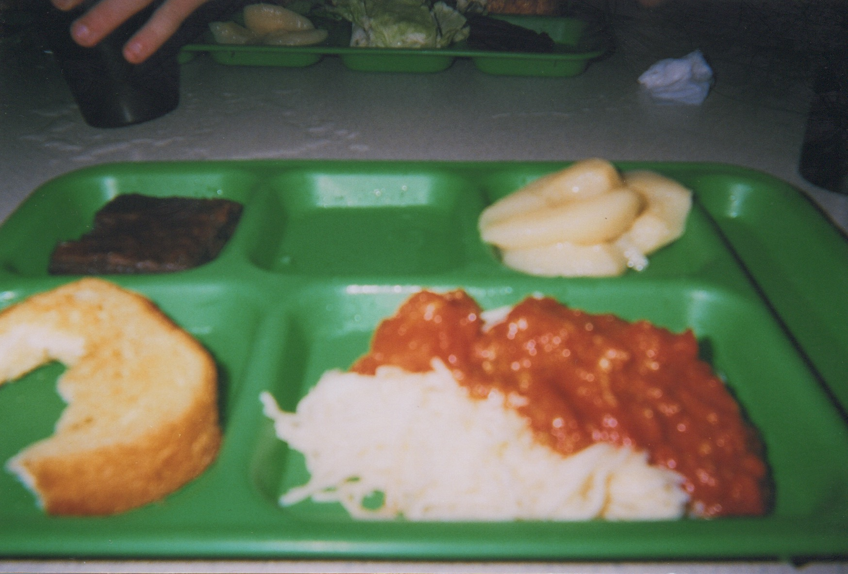
untitled. Circa 2009. Inkjet print, 6 x 4 in.

figure 2
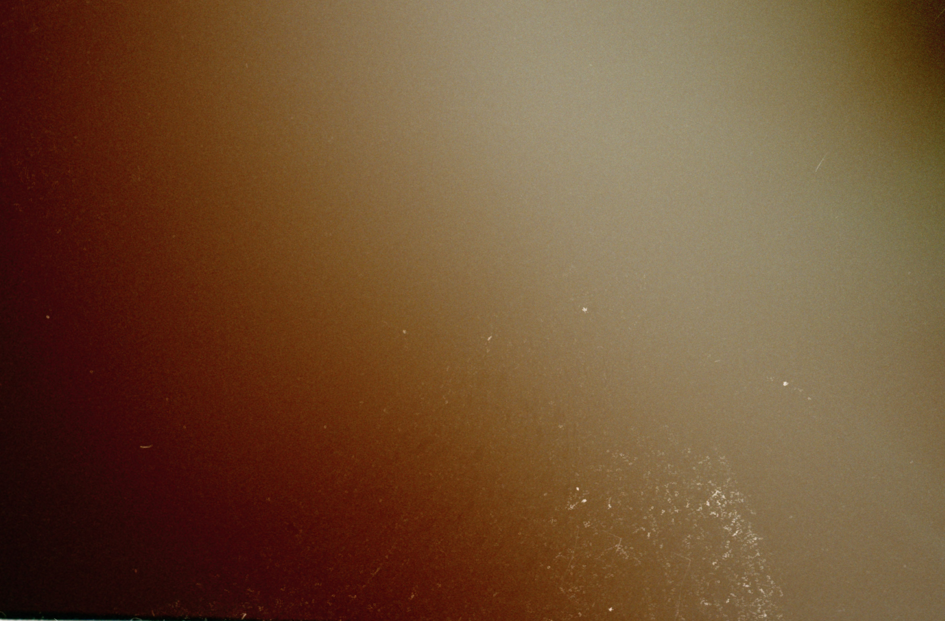
ambient_1. 2017. Archival pigment print, 6 x 4 in.

figure 3
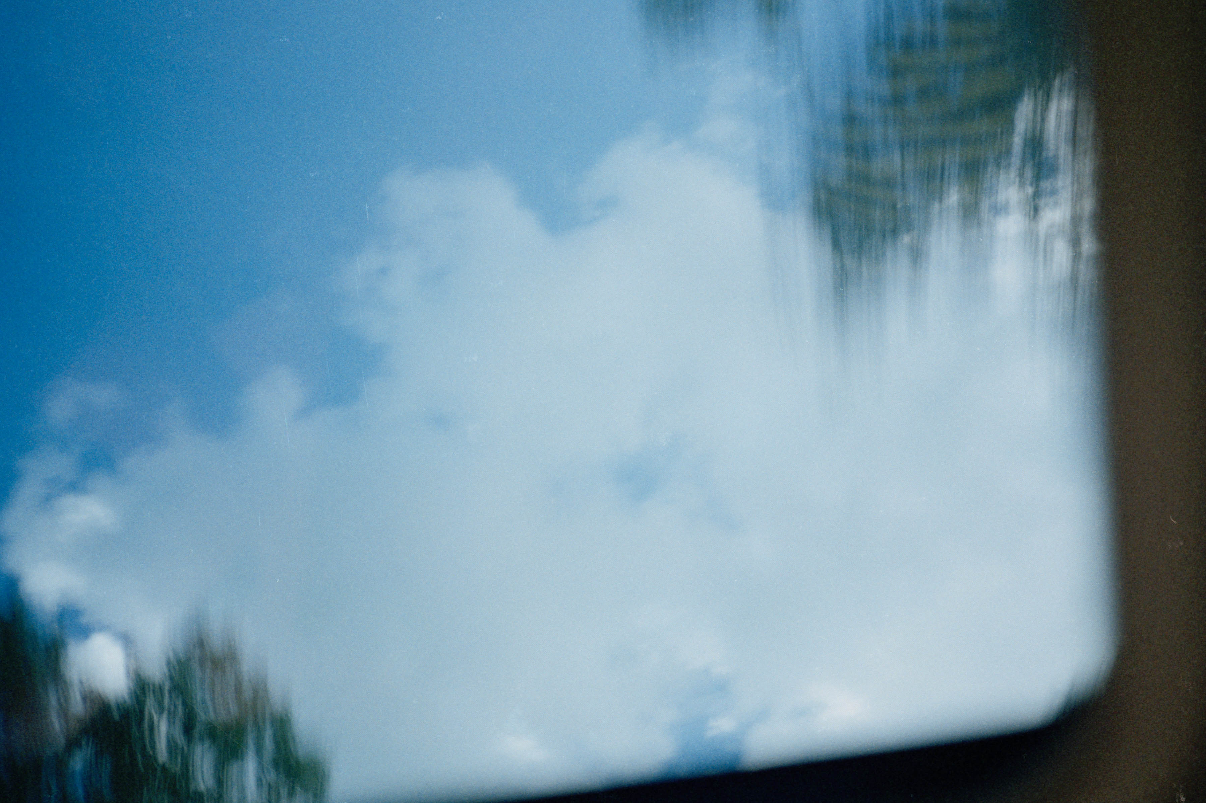
ambient_2. 2017. Archival pigment print, 6 x 4 in.

figure 4
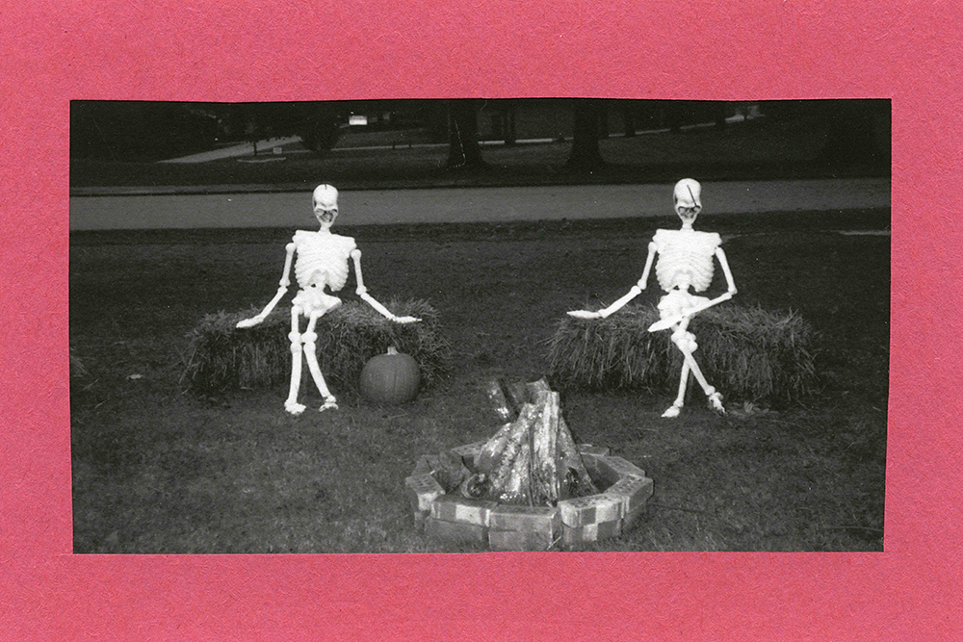
skellies. 2017. Archival pigment print, construction paper, 6 x 4 in.

figure 5
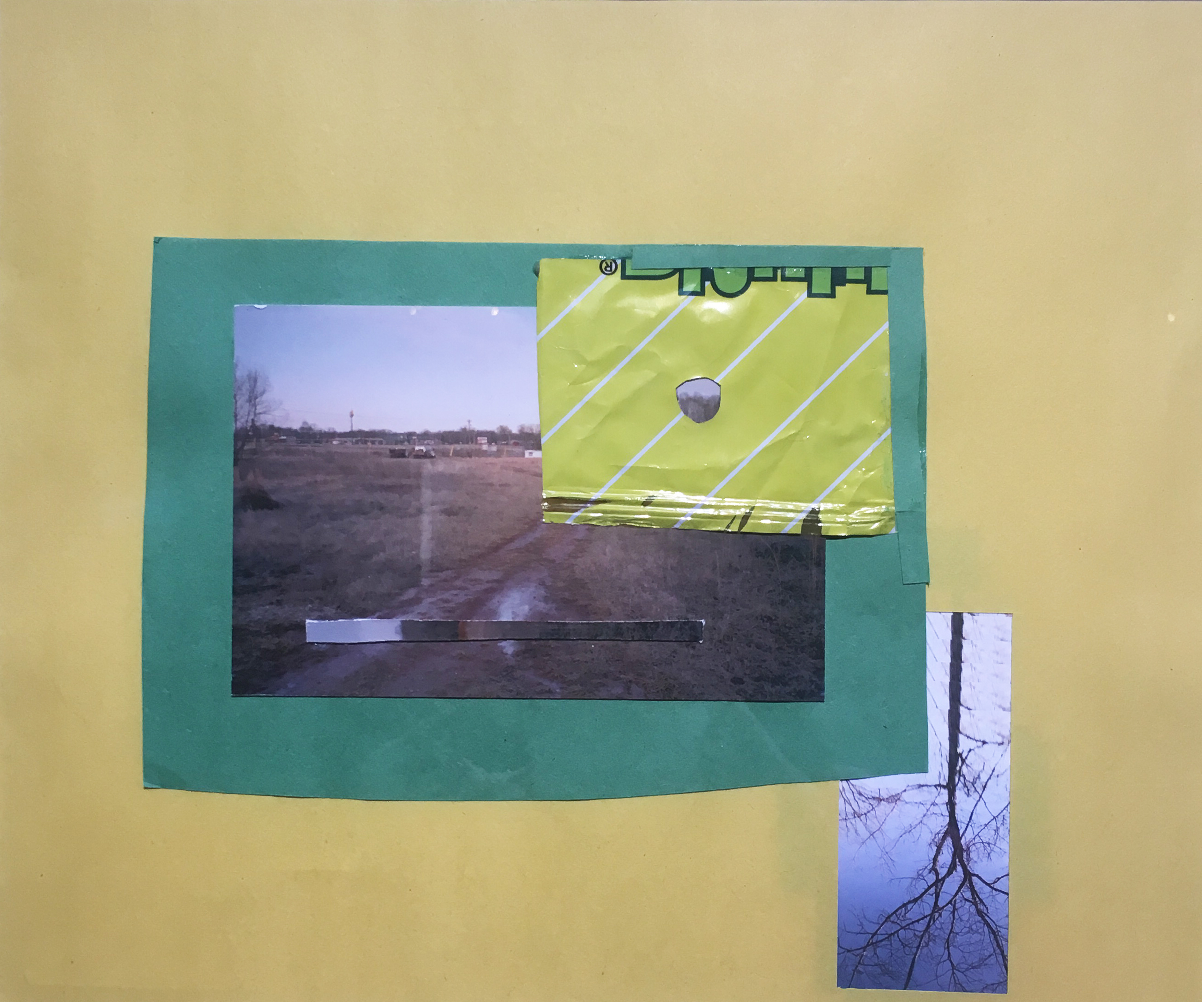
yellow. 2018. Archival pigment print, construction paper, funyuns wrapper, 11.5 x 8 in.

figure 6
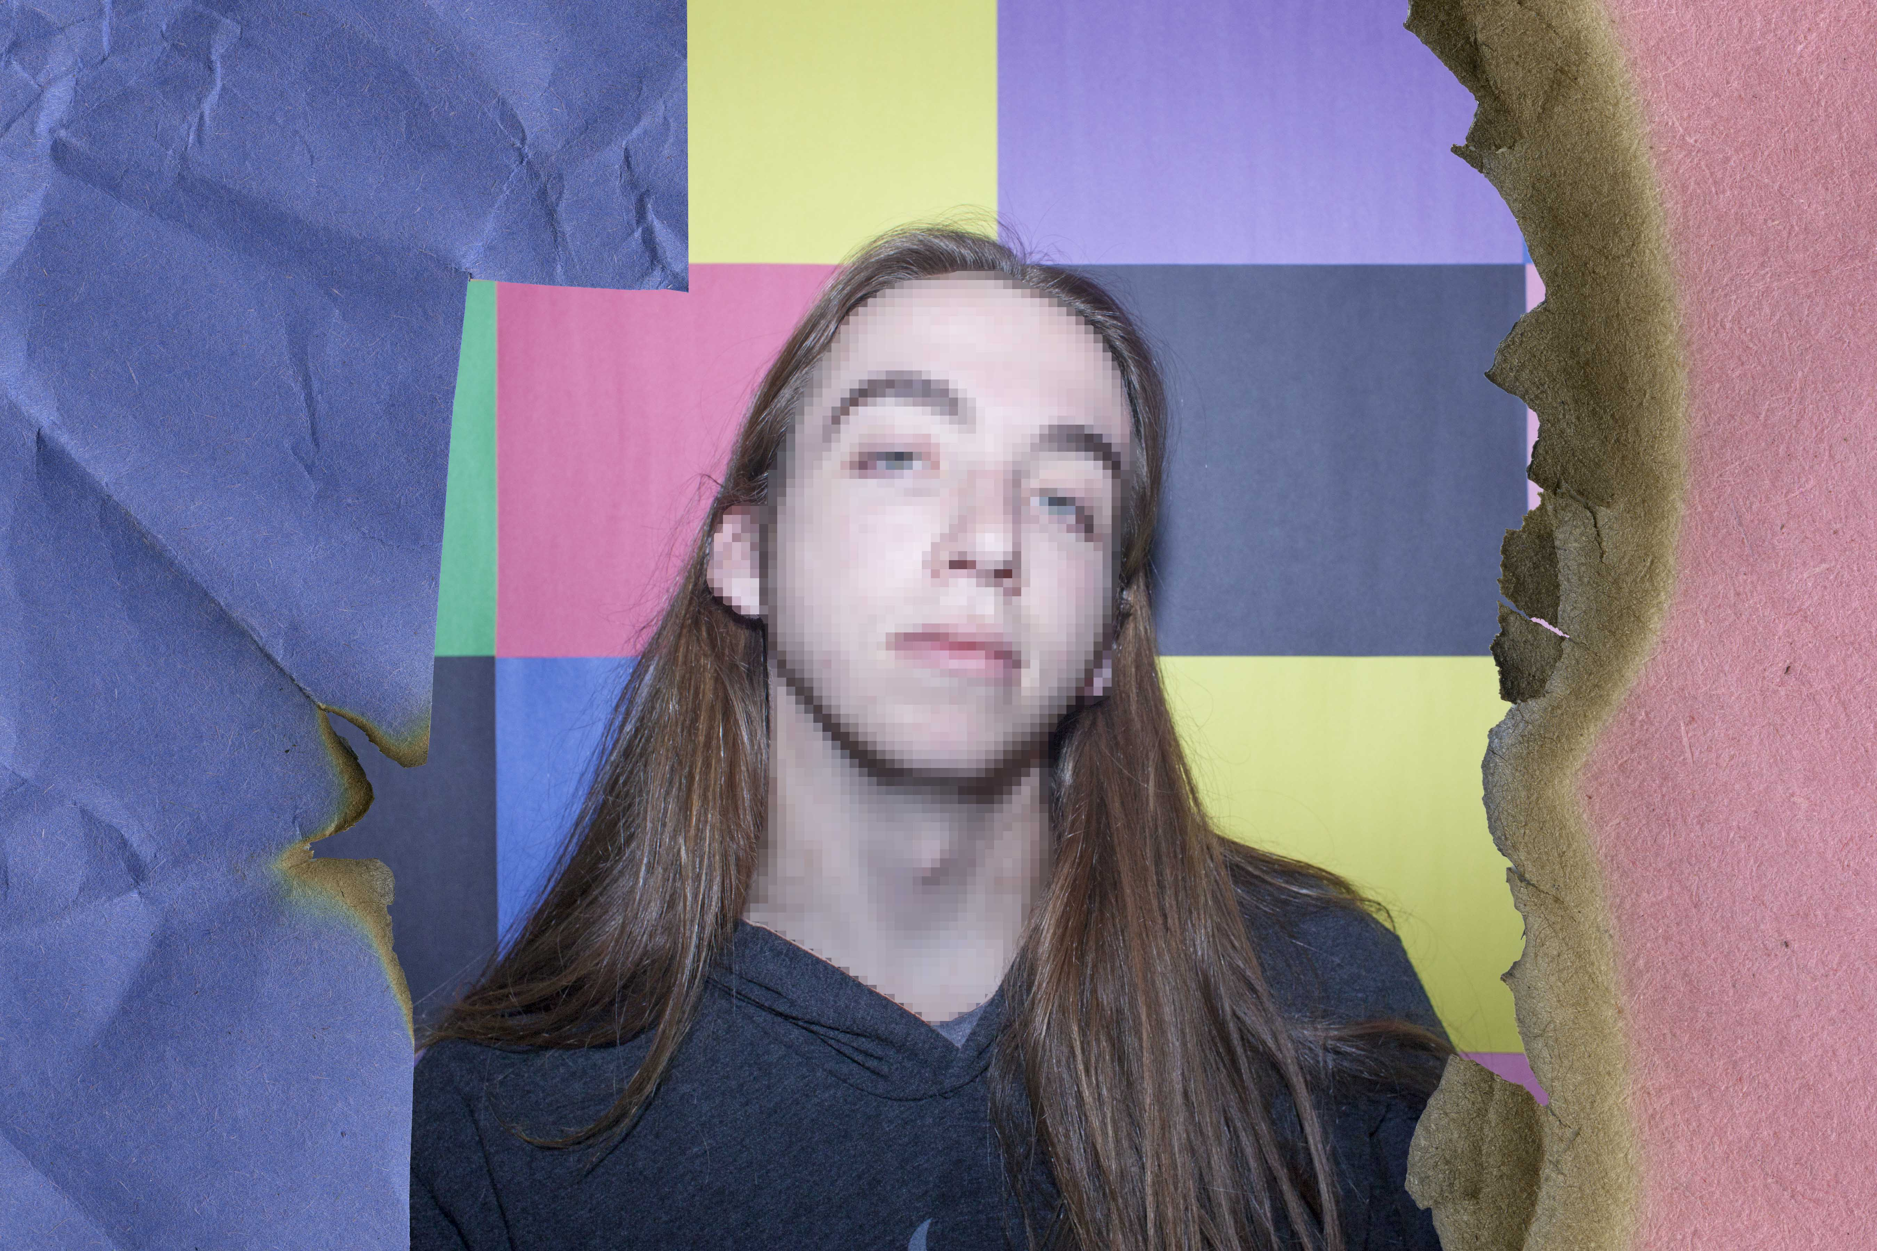
levi. 2018. Archival pigment print, 18 x 12 in.

figure 7
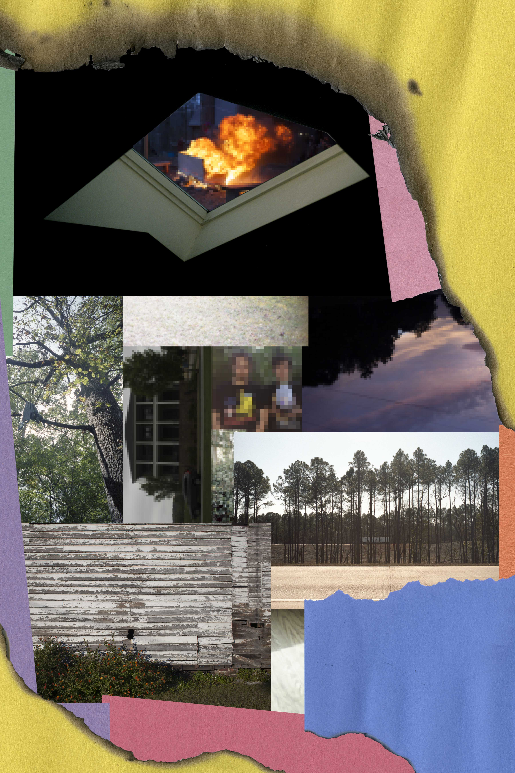
untitled. 2018. Archival pigment print, 12 x 18 in.

figure 8
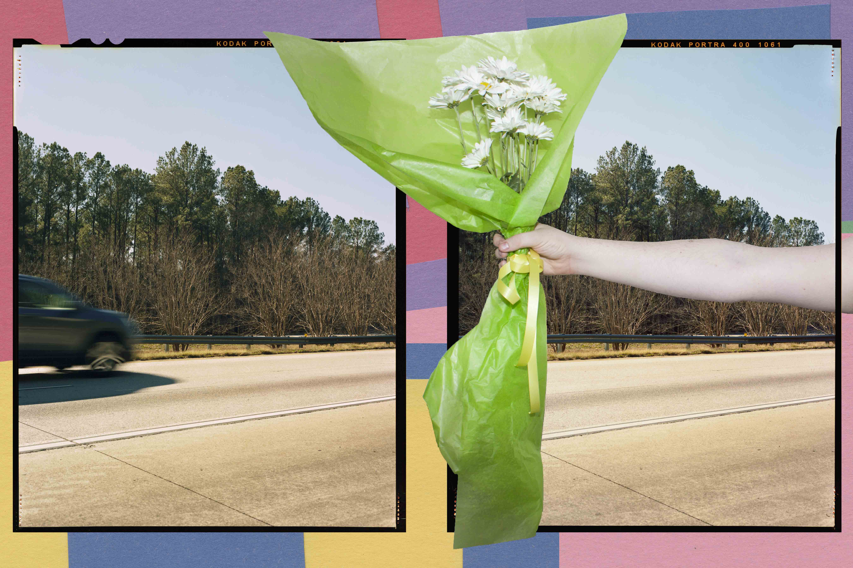
florid_offering. 2018. Archival pigment print, 18 x 12 in.

figure 9
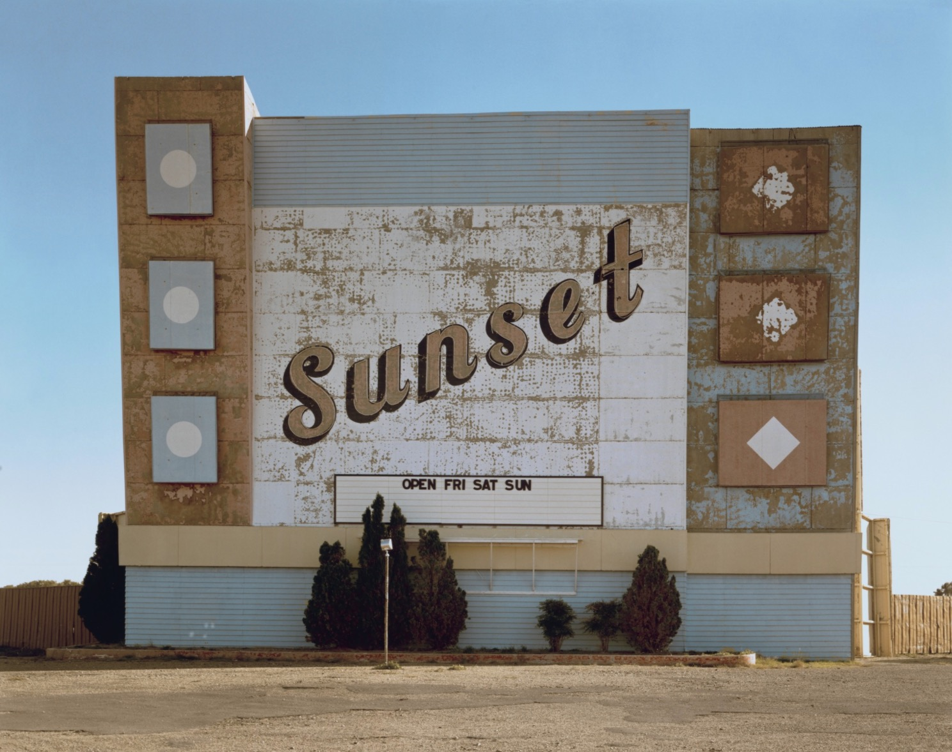
West 9th Avenue, Amarillo, Texas, October 2, 1974. 1974. STEPHEN SHORE. Chromogenic color print, 17 x 21 3/4 in. Digital collection of the Museum of Modern Art, New York.

figure 10
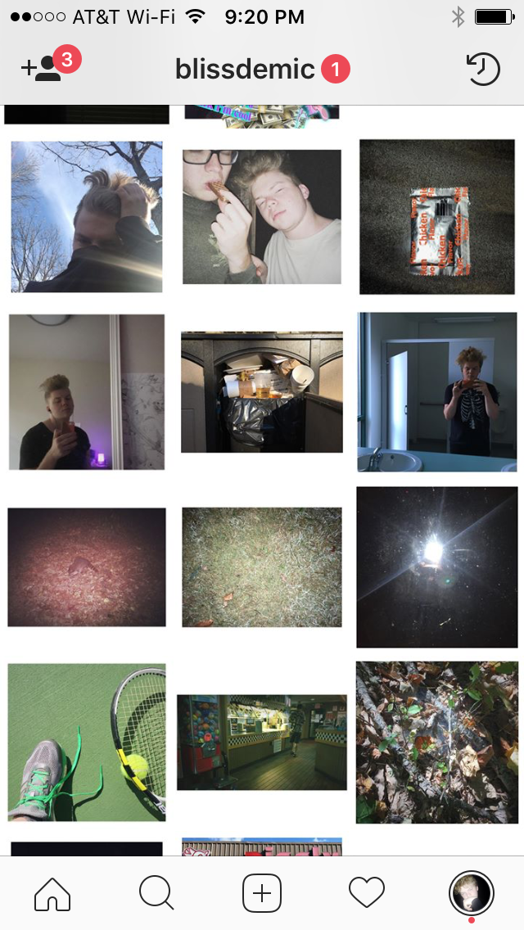
screenshot of my iphone photography instagram

